ROADMAP

Hippo CMS v7.0

Hippo Repository v2.0

Hippo Portal v1.0

Hippo Enterprise Content Platform

DRAFT V0.1

March, 2007
Arjé Cahn
Table of Contents
ROADMAP 1
Hippo CMS v7.0 1
Hippo Repository v2.0 1
History 3
Open source principles 4
Open source principles for extensions 4
Open source “way of development” 4
Development standards 4
Target audience 5
Target languages, technologies 5
Frontend samples 5
Test environment 5
Main goals 6
Usability, extendibility, interoperability, integration and administration 6
Central point for information management 6
Goals 7
User experience (Easy to understand and use) 7
0WAI 8
Extendibility (Easy to extend) 9
Interoperability and integration (Easy to integrate with external systems) 9
Easy to administer 10
A central point for information management 10
Technical requirements 12
Open questions 12
Main differences from previous architecture 13
TODO 13

History
The first stable distribution of Hippo CMS version 6 was released in June 2004. This new release introduced a fresh architecture where Hippo CMS, a frontend application and the content repository were seperated in different server applications. This seperation of concerns on setup level has been one of the main drivers for the success of Hippo CMS v6.0. It allowed for complex integrations with external systems while keeping a strong focus on a standardized user interface for the end-user.
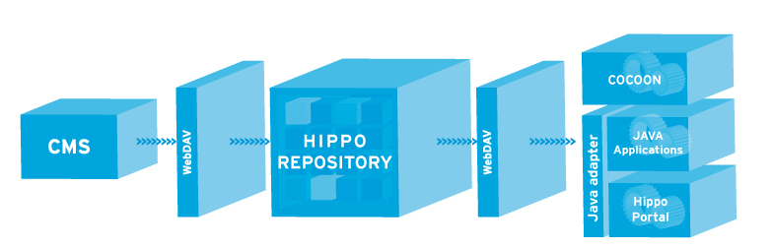
The focus on standardized protocols and XML technologies opened up the possibilities needed for enterprise wide CMS usage. Scalability and load balancing functionalities have added to the stability of the platform and allowed it to be used in the largest, content rich environments.
A familiar user interface driven by AJAX technologies to update only those parts of the application that needed to do so brought wide user acceptance.
On the developer's side, the concept of deployments and custom builds allowed external developers to setup and use the Hippo CMS platform for a diverse set of applications.
All of these developments combined have led to the current stable v6.04 release, rich in functionalities and possibilities.
They have also inspired developers and customers to raise ideas and whishes that go far beyond what's possible today. But the architectural concept has proven itself, and those new ideas only intensify the feeling that we're on the right track.
We are facing new horizons and need to take that leap to jump to the next level of extendibility, user experience and scalability.
Together with the HippoCMS.org community, Hippo will be driving the development of the future version of the Hippo Content Platform, consisting of Hippo CMS v7, Hippo Repository v2 and Hippo Portal v1.

Open source principles
Hippo strongly believes in the open source way of development, and develops all of its software under the following conditions, and in this order:

- Re-use existing open source components and knowledge where possible
- Discuss new code and ideas in the open source community
- Where no viable open source alternative is available, release new code in the open source community

As a side principle, all code should be Apache Software License v2.0 compatible. Where a non-ASL compliant component is used, enough abstraction should be implemented to offer interchangability with an ASL-compliant alternative, and such an alternative should be offered and tested.

Open source principles for extensions
Extensions developed by or for external parties can be released under any license, as long as this does not have implications for the license for the core code in any way (viral or other).

Open source “way of development”
Being an open source system, Hippo CMS allows insight in all the code, bugs, discussions among developers and the roadmap. Hippo deliberately exposes its development cycle so customers have insight in the progress and the state of the software it delivers.
Development of Hippo CMS is done in continuous circles, adding functionalities and releasing new versions on a high frequency basis. Whenever new and unexpected functionalities are required, they can be picked up and added to the system in a relatively short timespan. Hippo CMS is designed to be extendible, as opposed to a black box application.

Development standards
- Short development cycles
- Release early, release often: weekly (?) releases
- Daily builds for Hippo CMS, Hippo Repository, Hippo Portal and all dependencies
- Daily integration tests between Hippo CMS, Hippo Repository, Hippo Portal and all dependencies
- Tests:
  - Java unit tests
  - Selenium webbrowser tests

- integration tests between all
Every friday, a working version will be released

Target audience
Developers
Developers at customers
Partners
Implementation parties

Target languages, technologies
Java (Cocoon, Struts, JSF, Wicket, Echo2)
Flash
Independent WebDAV server (Ruby, .NET)

Frontend samples
Poll
Forum
Wiki
Blog
Flash connector

Test environment
Java unit tests
User interface functional tests. Selenium.
Integration tests for extensions

Main goals
These goals define in the broadest sense what the next release of the Hippo Content Platform should provide as a whole.

Usability, extendibility, interoperability, integration and administration
The Hippo Content Platform will be easy to understand, use, extend, integrate with external systems, and administer.

Central point for information management
The Hippo Content Platform will act as a central point for information management, with its main focus on a generic content repository that allows for integration with a diverse set of applications.

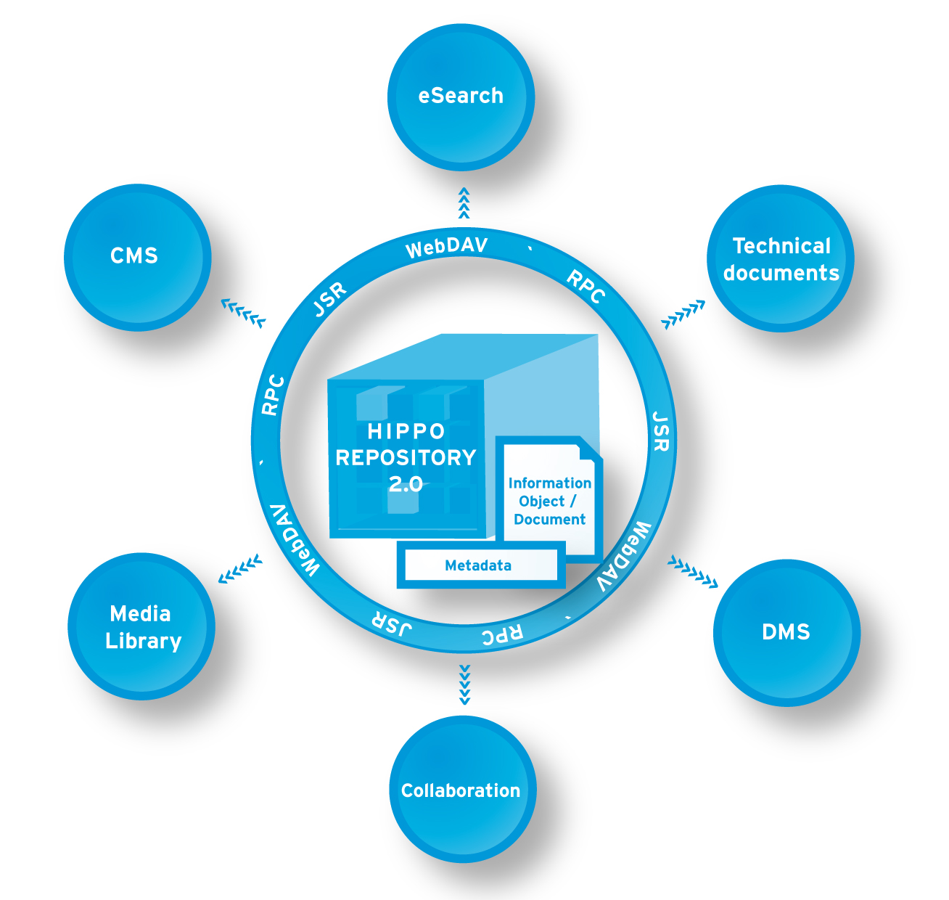

Goals
These goals define what the Hippo Content Platform needs to confirm to for the different terms mentioned in the main goals.

User experience (Easy to understand and use)
An excellent end user experience is the primary concern when designing and developing the Hippo CMS user interface. Any user of Hippo CMS, in any language and on any platform, should be able to comfortably work with the CMS UI. The productivity of the user should go up.
For developers, the API of the platform should be setup in a consistent and understandable way and should follow common best practices and patterns from the open source Java world.
Subgoals:
- High performance (“snappy”) user interface
- Platform independent
- All multilingual
  - Language switch button
  - Remember user language in profile
- Communication with peers (messaging, inbox, ..)
- Customizable look and feel
- User permissions, profiles
- Recognizable and predictable user interface behaviour
  - Mimic Windows-like user interface behaviour
  - Predictable copy paste from Word, Windows
- Management tools (statistical feedback, reports)
  - Dashboard queries
    - "Recent changes" list
    - Number of documents, editors, changes, ..
    - What's been recently published / what will go live soon
    - Queries to be defined by user, and saved for use on dashboard
  - Management info
    - How many changes

- Simplified template development
  - Template editing from within CMS interface
- Micro updates
  - In-page direct editing of single fields through AJAX interface (“Flickr way”)
  - User permissions / workflow on a per-field basis
  - Backend templates work with micro updates. Clicking a field will make it editable. Save action is not performed on the complete document but on a per-field basis.
- Browser back button support in Hippo CMS
- AJAX update inter-portlet UI elements
- Dragdrop functionalities across UI portlets
- Preview functionality from CMS user interface
- Preview on labels (across all labels, ie preview “Release 1”, “Christmas edition”)
- Translation guidance
  - Show different language versions in one view, allow translators to easily translate
- History view
  - Who did what
  - See changes in context (rich diff)
- Navigation through CMS interface
  - Guide user in finding what he needs to change (faceted interface)
  - Use hierarchical views where appropriate
  - Use relational views where appropriate
  - Use faceted views where appropriate
- Workflow
  - TODO list
  - “Inbox” view
  - Clear presentation of workflow state of objects
- “Click efficient”
  - Lower the number of clicks needed to perform a common end user task as much as possible
- Meta information editor
  - Tagging editor
- Usability for disabled

WAI
- User login/logoff
  - Single sign on support (Portal / CMS / ...)
  - Remember login functionality
  - Password reminder, request new password
  - Logoff button always available
  - Keep connection alive as long as editor is open on user's screen
  - Warn user when connection drops or he's logged off (Gmail style)
- Navigation editor and picker
- Thesaurus editor and picker
- i18n editor and picker
- Provide user feedback on status of the document, whether actions succeeded or not

Extendibility (Easy to extend)
Hippo CMS, Hippo Repository and Hippo Portal are building blocks that can be extended in a standardized way by developers to customize the system to the needs of the customer. Extensions written for such a customized environment will be stored seperately from the core codebase, can be tested with new versions and can be supported by either Hippo or a third party. A clear API helps developers setup extensions, who can share their contributions in a seperate Hippo Extensions community.
Subgoals:
- Workflow extendibility
  - Allowing integration with business logic from external processes

Interoperability and integration (Easy to integrate with external systems)
Hippo CMS, Hippo Repository and Hippo Portal are building blocks that can be combined with other building blocks to form integrated solutions that fit perfectly into the information infrastructure needs of the customer.
Whenever the choice for a protocol, storage format or interface is needed, widespread open standards are preferred. Storage is done in a
All protocols should be using widely adopted open standards.

Subgoals:
- Authenticating against external servers (LDAP, Active Directory, NDS)
- Integration in portal environments (JSR-168, JSR-286)
- Database independent (Derby, MySQL, Oracle, MS SQL)
- Conform common repository standards (WebDAV, JSR-170, JSR-283)
- Ability to use and index meta information from external systems ()

Easy to administer
The administration of a Hippo CMS or Portal instance should be
Subgoals:
- Deployment in common containers as single WAR for each component (Tomcat, Websphere, Weblogic, JBoss)
- 'Easy install'
  - A clean deploy of the Hippo Repository should work out-of-the-box and not need manual tweaking of databases

- Clustering / load balancing
- Error / conflict reporting to system administrator
- Workflow administration using webbased user interface
  - Adding steps, roles, etc

A central point for information management
- Handle images and perform image manipulation
- Store video and audio or index and use video, audio from external systems
- Handle XML documents for pure text
- Handle any type of binary format, like PDF, Word, Excel, etc
- Document management (operating system integration, integration with desktop applications, Word, Excel, Outlook)
  - CIFS implementation (Windows shared network drive)
- Repository object model
  - An object can be
    - A document descriptor (of XML document, binary, or reference to an external object)
    - A container of objects, with ordering
  - An object consists of
    - A unique numerical identifier
    - One semantical meaning (represents 1 semantical object, regardless of language, version or workflow state)
    - Different languages
    - Revisions per language
    - A workflow state per language, per revision, per version on the object as a whole, and on a group of objects together
    - Revision on the complete object
    - References to other objects, with ordering
    - Meta information, tags, properties
    - Version labeling (not-versioned in the object, but on the object as a whole, part of a group of objects. ie. “Release 1”)
  - Objects should be
    - 'Movable' in the hierarchical view (ie, get retagged)
    - Renameable
  - Bag of objects
  - Hierarchical structure is a result of a mapping on the tags attached to object
  - An object can show up in many locations in the (virtual) hierarchy
- Users / groups / roles
- Indexing and searching

- Workflow
  - A workflow state per language, per revision, per version on the object as a whole, and on a group of objects together
  - Knowledge driven workflow
    - Based on tagging and user knowledge (workflow rules to match tags on objects with tags on users)
    - Documents show up in 'inbox' based on tagging
- Support for integration with:
  - Mailinglist functionality (personalized or not)
  - Microsoft Office importer (server side conversion of Office to XML)

Technical requirements
- Transactional
- Critical error messages on any level should propagate back to the client where the user should be notified appropriately
- Support for different browser based editors: form based, Xopus

Open questions
- DASL as primary query language?

Main differences from previous architecture
- Detach documents from a strict location in a fixed hierarchy
  - Allowing different views on the same dataset
  - Allowing workflow structures based on business rules other than hierarchy
    - Knowledge based workflow
- Move versioning and workflow into deeper layers in Hippo Repository
  - Higher grade of seperation between business logic and CMS

TODO
- Walk through Jira 'CMS' issues
- Walk through Evernote ideas
- VNU issue list
- backwards compatibility, or migration path

